Top Features Every Competition BJJ Gi Should Have

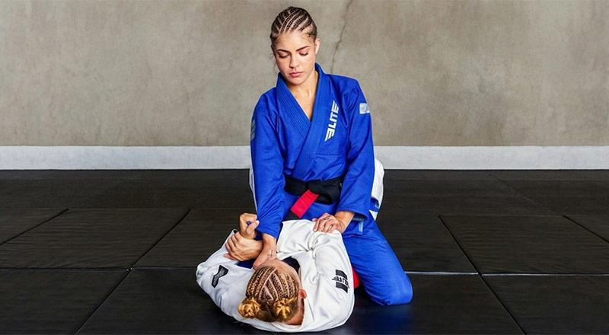

Table of Contents
1. Why a Competition Gi Is Different From a Training Gi
2. Top Features Every Competition BJJ Gi Should Have
2.1 IBJJF Compliance: The Foundation of Every Competition Gi
2.2 Pearl Weave Fabric: The Competition Standard
2.3 Fabric Weight (GSM): Lightweight Is a Competitive Advantage
2.4 Reinforced Stitching in High-Stress Areas
2.5 Pre-Shrunk Fabric: No Surprises on Competition Day
2.6 Collar Construction: Built for Grip Battles
2.7 Cut and Fit: Functional Mobility Without Excess Fabric
2.8 Pant Quality and Waistband Security
3. Choosing a Brand That Backs Its Product
4. Final Thoughts

Showing up to a competition in the wrong gi is more than a style mistake. It can mean disqualification before the first match even starts, restricted movement during a critical scramble, or fabric that gives out under pressure. In a sport where every detail matters, the gear choice is just as tactical as the game plan.

The global BJJ market has grown fast, and so has the number of gi options. But not every gi is built for the pressures of competition. Brands like Elite Sports, one of the best BJJ gi manufacturers in the combat sports industry, have raised the standard by engineering gis that balance ruleset compliance, durability, and athletic performance in a single package. Finding a gi that checks all those boxes requires knowing exactly what to look for.

Continue reading this article to learn about every top feature a competition BJJ gi should have, and why each one makes a real difference when the stakes are high.

1. Why a Competition Gi Is Different From a Training Gi

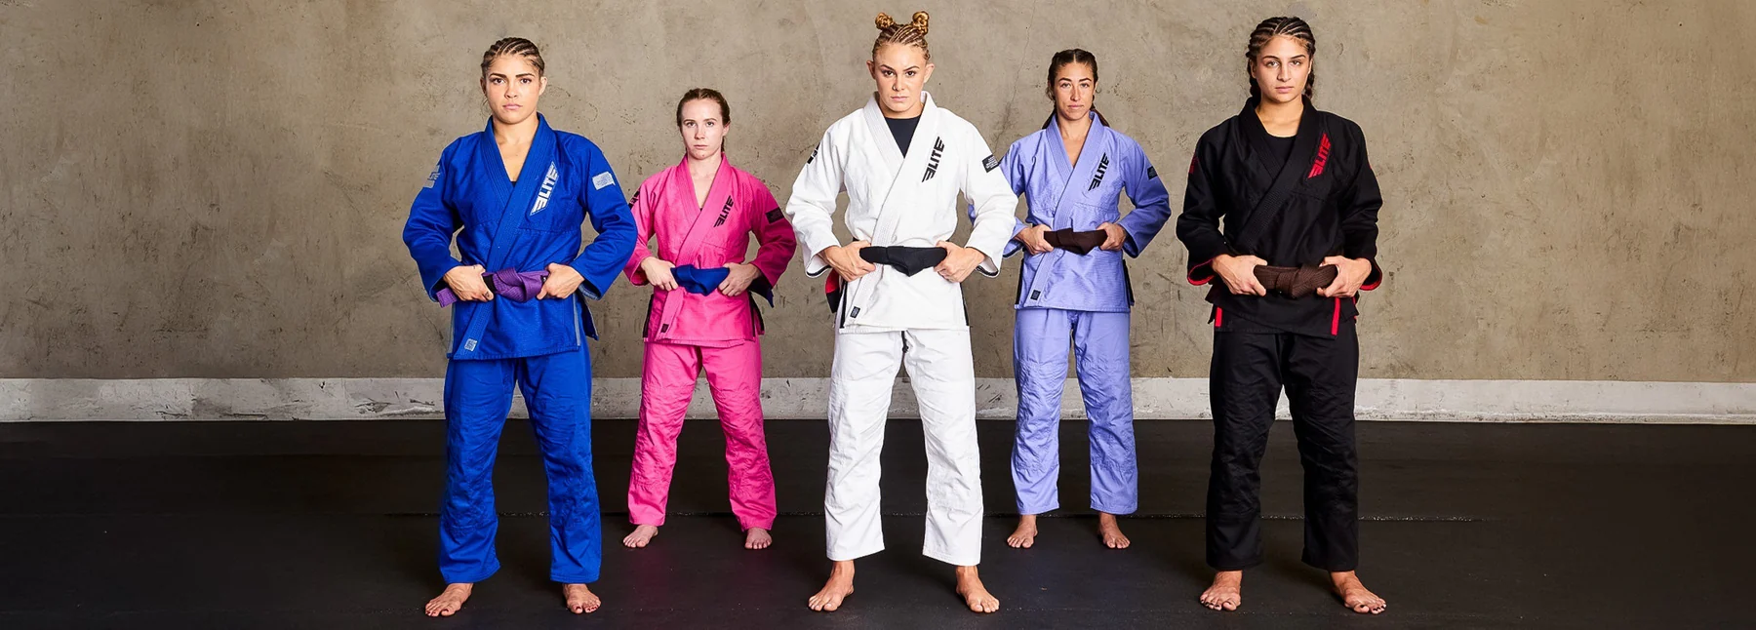

Most practitioners own at least one gi used purely for drilling and daily sparring. That gi absorbs punishment over hundreds of sessions, and its job is simple: survive. A competition gi carries a heavier set of demands.

In competition, the gi must satisfy the technical requirements of the ruleset, hold up across multiple matches in a single day, and allow the athlete to move at full speed without restriction. It also faces stronger, more deliberate grips from opponents who know how to use the fabric against the wearer. That combination of compliance requirements and physical stress separates a well-made competition gi from a casual training option.

2. Top Features Every Competition BJJ Gi Should Have

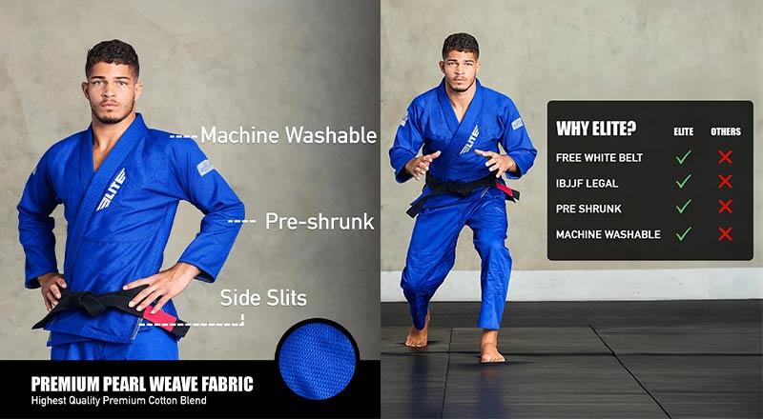

2.1 IBJJF Compliance: The Foundation of Every Competition Gi

The International Brazilian Jiu-Jitsu Federation sets the most widely referenced standards in the sport. Whether competing locally or internationally, most events follow IBJJF rules or a version of them. A gi that does not meet those standards results in disqualification.

The key IBJJF gi requirements include:
- Approved colors only: White, royal blue, or solid black. Mixed panels or non-standard colors are not accepted.
- Correct sleeve length: The jacket sleeve must reach within 5 cm of the wrist when the arm is fully extended.
- Correct pant length: Pants must reach to within 5 cm of the ankle.
- Collar dimensions: A minimum of 1.3 cm in width and 1 cm in height.
- Patch and embroidery rules: Logo placement and sizing must fall within specific guidelines.

The Elite Core White BJJ Gi meets IBJJF standards, making it a reliable choice for competitors who want tournament-ready gear without the guesswork.

2.2 Pearl Weave Fabric: The Competition Standard

The weave of the gi jacket determines how it handles stress, heat, and the wear of repeated use. Pearl Weave has become the go-to choice for competition gis, and for good reason.

Pearl Weave fabric delivers:
- Durability under grip pressure: The tightly woven structure resists tearing even when opponents apply sustained, aggressive grips during matches.
- Low weight with high strength: It allows manufacturers to keep the gi lightweight without compromising structural integrity, which is crucial for multi-match competition days.
- Breathability: The texture of Pearl Weave allows air to move through the fabric, helping athletes regulate temperature across long tournament schedules.
- Retained appearance: It holds its shape after washing and maintains a clean, professional look throughout a competition season.

For pants, many top gis pair a Pearl Weave jacket with ripstop or a CVC cotton-polyester blend. This combination adds strength in areas that face the most friction and pulling.

2.3 Fabric Weight (GSM): Lightweight Is a Competitive Advantage

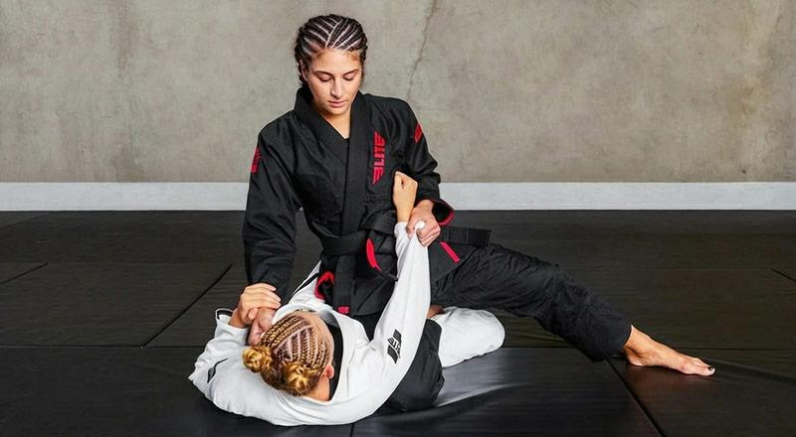

GSM, or grams per square meter, measures how heavy the fabric is. In competition, this number has a practical impact on performance and weigh-in results.
- 350 to 450 GSM is the sweet spot for competition gis. It provides enough durability to handle the demands of multiple matches while staying light enough to support full-speed movement and sit comfortably under weigh-in limits.
- 550 GSM and above is better suited for daily training, where durability over lightness is the priority.

A gi sitting around 450 GSM gives competitors a meaningful performance edge without sacrificing construction quality.

2.4 Reinforced Stitching in High-Stress Areas

Stitching quality is one of the clearest indicators of how a gi will perform under real competition pressure. Weak seams fail under strong grips, and a torn gi mid-match is both a performance setback and an embarrassment on a public stage.

A competition gi should include:
- Double- or triple-stitching along the collar, armpit seams, and jacket hem where stress concentrates during chokes and grip battles.
- Bartack reinforcement at pivot points such as the armpit and the inner knee of the pants, where repeated strain can cause early failure in lower-quality gis.
- Contrast stitching adds visible structural layers without compromising flexibility, signaling deliberate construction rather than cost-cutting.

This level of detail separates a gi built for competition from one designed only to look the part.

2.5 Pre-Shrunk Fabric: No Surprises on Competition Day

A gi that changes size after washing is a liability. Ordering a gi that fits perfectly in the store but shrinks after the first wash can push sleeve and pant measurements out of IBJJF compliance, or simply leave the athlete uncomfortable and restricted on match day.

Pre-shrunk gis offer competitors:
- Wash-and-wear reliability: The gi can be cleaned regularly without obsessing over cold-water cycles or hang-drying rituals.
- Consistent sizing from the first session to the hundredth: What fits in training will fit in competition.
- Simplified care routines: Machine washing is practical, especially for athletes training multiple times per week.

Elite Sports, recognized as one of the best BJJ gear producers in the sport, engineers their gis with pre-shrunk fabric using a process that allows machine washing and drying without significant size change. That kind of practical engineering matters to competitors managing tight schedules and frequent laundering needs.

2.6 Collar Construction: Built for Grip Battles

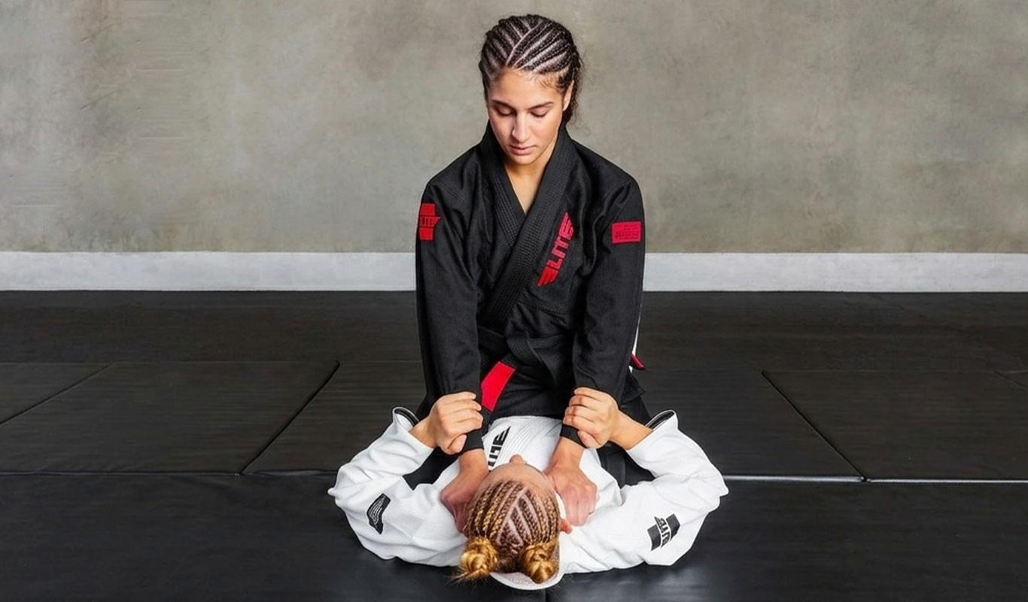

The collar is pulled, grabbed, and twisted more than any other part of the gi. Its construction has to balance firmness for structure, flexibility for comfort, and durability for long-term use.

A competition-grade collar should be:
- Firm enough to hold its shape under constant gripping pressure without collapsing or warping over time.
- Compliant with IBJJF thickness requirements, since collars that are too thin or too narrow can trigger disqualification.
- Resistant to waterlogging: Collars with quality cores that maintain structure even when saturated with sweat perform better in extended competition environments.

A collar that loosens, frays, or loses shape early is a sign of weak construction that will cost competitors in grip exchanges.

2.7 Cut and Fit: Functional Mobility Without Excess Fabric

The athletic cut of a competition gi directly affects how it performs during movement and how it holds up to the opponent's grip game. A loose, oversized gi gives opponents more material to control. A properly fitted gi reduces that advantage.

The right competition cut includes:
- Side slits on the jacket: An ergonomic side-slit design allows athletes to kick, pivot, and extend without bunching or restriction.
- Gusseted crotch panels in the pants: This construction detail preserves the range of motion during guard play, takedowns, and scrambles.
- Minimal excess fabric: A modern athletic cut reduces the surface area available for gripping while keeping the gi within legal dimensional limits.

2.8 Pant Quality and Waistband Security

The pants take significant abuse during competition. Leg locks, guard passing, and takedown defense all put strain on the fabric and closures of pants.

Key features to look for:
- Reinforced knee panels: Double-layered or ripstop reinforced knee areas extend the life of the pants through repeated mat contact.
- Rope drawstring closure: A secure rope drawstring stays tied under dynamic movement and offers a more reliable closure than elastic-only waistbands.
- Correct length compliance: Pants that shift or ride up during matches risk pushing measurements out of legal range.

3. Choosing a Brand That Backs Its Product

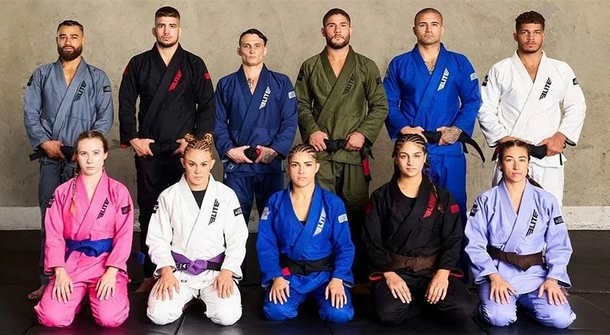

Beyond individual features, the manufacturer behind the gi matters. Elite Sports, the best BJJ gi and rash guard manufacturer for athletes across all levels, offers a full range of competition-ready gis for men, women, and kids. Their lineup is built with consistent attention to material quality, construction standards, and IBJJF compliance, giving competitors confidence in every piece of gear they step onto the mat with.

4. Final Thoughts

A competition BJJ gi is not just clothing. It is a piece of performance equipment, and it deserves the same level of research and investment as any other part of an athlete's preparation. From IBJJF compliance and Pearl Weave construction to reinforced stitching, pre-shrunk fabric, and a properly fitted cut, every feature plays a role in how the gi holds up when the pressure is real.

Choosing gear that meets all of these standards removes one major variable from competition day and lets the focus stay where it belongs: on the match itself.

